# Life Cycle Plan (LCP)



**Team 02**

|  |  |  |
| --- | --- | --- |
| **Member Name** | **Role** | **Email** |
| Rajat Verma | Project Manager, Lifecycle Planner, Dev | [rajatver@usc.edu](mailto:rajatver@usc.edu) |
| Preksha Gupta | Software Architect, Operational Concept Engineer | prekshag@usc.edu |
| Mangalore Rakesh Shenoy | Software Developer, Prototyper | mangalos@usc.edu |
| Ankit Gupta | Requirements Engineer, Tester | guptaank@usc.edu |
| Snehal Surendra Desai | Prototyper, Software Developer | snehalsd@usc.edu |
| Lu Wu | Quality Focal Point, Tester | wulu@usc.edu |
| Heidi Negron-Arroyo | IIV and V, Feasibility Analyst | negronar@usc.edu |

**10/15/2016**

# Version History

| Date | Author | Version | Changes made | Rationale |
| --- | --- | --- | --- | --- |
| 10/12/16 | Rajat | 1.0 | Estimated Project Efforts and Schedule  Completed Resources Section, Milestones and products | Initial draft for use with FCR ARB package for VYMA |
| 10/15/16 | Rajat | 1.1 | Completed Responsibilities and Approach Section | Completed for final submission of FC Package |
| 11/19/16 | Ankit | 1.2 | Completed Iteration Plan Section | Initial draft for As-Built Package |
| 12/4/16 | Preksha | 1.3 | Added the Transition Plan and Support Plan Section | Completed for final submission for As-Built Package |

# Table of Contents

Life Cycle Plan (LCP) i

Version History ii

Table of Contents iii

Table of Tables v

Table of Figures vi

1. Introduction 1

1.1 Purpose of the LCP 1

1.2 Status of the LCP 1

1.3 Assumptions 1

2. Milestones and Products 2

2.1 Overall Strategy 2

2.2 Project Deliverables 3

3. Responsibilities 6

3.1 Project-specific stakeholder’s responsibilities 6

3.2 Responsibilities by Phase 6

3.3 Skills 9

4. Approach 11

4.1 Monitoring and Control 11

4.2 Methods, Tools and Facilities 11

5. Resources 13

6. Iteration Plan 22

6.1 Plan 22

6.1.1 Capabilities to be implemented 23

6.1.2 Capabilities to be tested 24

6.1.3 Capabilities not to be tested 25

6.1.4 CCD Preparation Plans 25

6.2 Iteration Assessment 25

6.2.1 Capabilities Implemented, Tested, and Results 25

6.2.2 Core Capabilities Drive-Through Results 26

6.3 Adherence to Plan 29

7. Transition Plan Error! Bookmark not defined.

7.1 Transition Objectives Error! Bookmark not defined.

7.2 Transition Strategy Error! Bookmark not defined.

7.3 Software and Site Preparation: Error! Bookmark not defined.

7.4 Stakeholders and Responsibilities: Error! Bookmark not defined.

7.5 Required Resources: Error! Bookmark not defined.

8. Support Plan: Error! Bookmark not defined.

8.1 Support Strategy Error! Bookmark not defined.

# Table of Tables

Table 1: Artifacts Deliverables in Exploration Phase 3

Table 2: Artifact deliverable in Valuation Phase 4

Table 3: Artifact deliverable in Foundations Phase 4

Table 4: Artifact deliverable in Development Phase 5

Table 5: Stakeholder's Responsibilities in each phase 6

Table 6: COCOMOII Scale Driver 13

Table 7: COCOMOII Cost Driver-Registartion System 14

Table 8: COCOMOII Cost Driver-Payment System 16

Table 9: COCOMOII Cost Driver-Migration 17

Table 10: COCOMOII Cost Driver-Announcement System 19

Table 11: COCOMOII Cost Driver-Event Calendar 20

Table 12: Construction iteration capabilities to be implemented 23

Table 13: Construction iteration capabilities to be tested 24

Table 14: Capabilities implemented, tested, and results 26

# Table of Figures

*Figure 1: Scale Factors …………………………………..................................................................14*

*Figure 2: EAF-Registration ……….…………………………………………………………………….15*

*Figure 3: EAF-Payment System ……………………...…………………………………..…………….17*

*Figure 4: EAF-Migration…………………………...……………………………………………..…….18*

*Figure 5: EAF-Announcement ………………………………………………………………... ………20*

*Figure 6: EAF-Event Calendar ………………………………………………………………... ……..21*

Introduction

#### Purpose of the LCP

* Making *plans, projections,* and *decisions* based upon the life cycle theory.
* Helps with *resource allocation* when considering how much to allot to various projects.

#### Status of the LCP

The status of this LCP is currently at the version number *1.1*, which will be submitted along with *Foundations Commitment Package*. This version will be reviewed with the necessary stakeholders and if there are no changes to be made, the latest version of this document will be delivered to the client.

#### Assumptions

* The duration of the project is *one semester* or *12 weeks* in Fall 2016
* The team consists of six on-campus students and one DEN student.
* All team members are taking only CSCI 577A for Fall 2016.
* The team adheres to Incremental Commitment Spiral Model (ICSM) and follows the guidelines defined for same.

Milestones and Products

#### Overall Strategy

*NDI/NCS Intensive Process:* All the capabilities (functions) of our system are delivered by COTS/ services like Squarespace, MailChimp and Stripe.

**Exploration phase**

**Duration:** 09/09/16-09/18/16

**Concept:** Identify operational concept, system and software requirements along with their architecture, and life cycle plan.

**Deliverables:** Client Interaction Report

**Milestone:** Valuation Commitment Review

**Strategy:** One Incremental Commitment Cycle, Risk assessment analysis.

Win-Win Negotiation Sessions

**Valuation phase**

**Duration:** 09/19/16-10/07/16

**Concept:** Perform win-win negotiations with Client, Develop operational concept, Identify main objectives, Constraints and Priorities, Assess and plans to mitigate risks, Explore Alternatives, Gather data on project feasibility evidence, Prototype the top risk items, Plan and manage project, Define quality and configuration policy.

**Deliverables:** Draft Foundations Commitment Package

**Milestone:** Foundations Commitment Review

**Strategy:** One Incremental Commitment Cycle, Risk assessment analysis.

Win-Win Negotiation Sessions, Planning Poker

**Foundations phase**

**Duration:** 10/08/16-10/21/16

**Concept:** Assess Project Status, Plan and Manage Project, Manage Project Quality, Develop the Prototypes with additional details and required features, Fix Defects, Develop Software Architecture.

**Deliverables:** Development Commitment Package, Draft Transition Readiness Review Package

**Milestone:** Development Commitment Review

**Strategy:** One Incremental Commitment Cycle, Risk assessment analysis.

**Development phase**

**Duration:** 10/22/16-12/05/16

**Concept:** Core Capability Drive, Developing and implementing the full system with required features. Performing unit, integration and regression testing. Project plan, recording project progress, Training the maintainer after developing the system about how to use the same, Transition Readiness Review

**Deliverables**: Core Capability Drive-Through Report, Transition Readiness Review Package, Project Archive

**Milestone:** Core Capability Drive, Transition Readiness Review

**Strategy:** Development, Testing, Training, Deployment

#### Project Deliverables

This section consists of project deliverables in each phase for VYMA project and its due date, format, and medium.

##### Exploration Phase

Table 1: Artifacts Deliverables in *Exploration Phase*

|  |  |  |  |
| --- | --- | --- | --- |
| **Artifact** | **Due date** | **Format** | **Medium** |
| Client Interaction Report | 09/16/2016 | .pdf | Soft copy |
| Win Conditions Report | 09/26/2016 | .pdf | Soft copy |
| Jira | Weekly Monday | Jira Ticket | Jira Website |
| Risk and Defect Report | Bi-weekly  Wednesday | .xls | Soft copy |
| Project Plan | Bi-weekly  Wednesday | .mpp | Soft copy |
| Progress Report | Bi-weekly  Wednesday | .xls | Soft copy |

##### Valuation Phase

Table 2: Artifact deliverable in Valuation Phase

|  |  |  |  |
| --- | --- | --- | --- |
| **Artifact** | **Due date** | **Format** | **Medium** |
| Top Risk Prototype Presentation | 09/30/2016 | .pptx | Soft copy |
| Draft Foundations Commitment Package   * Operational Concept Description (OCD) * Life Cycle Plan (LCP) * Feasibility Evidence Description (FED) * Prototype (PRO) * System and Software Architecture Description (SSAD) | 10/14/2016 | .doc .pdf | Soft copy |
| Jira | Weekly Monday | Jira Ticket | Jira Website |
| Risk and Defect Report | Bi-weekly  Wednesday | .xls | Soft copy |
| Project Plan | Bi-weekly  Wednesday | .mpp | Soft copy |
| Progress Report | Bi-weekly  Wednesday | .xls | Soft copy |

##### Foundations Phase

Table 3: Artifact deliverable in Foundations Phase

|  |  |  |  |  |  |
| --- | --- | --- | --- | --- | --- |
| **Artifact** | | **Due date** | **Format** | | **Medium** |
| Jira | | Weekly Monday | Jira Ticket | | Jira Website |
| Risk and Defect Report | Bi-weekly  Wednesday | | .xls | Soft copy | |
| Project Plan | Bi-weekly  Wednesday | | .mpp | Soft copy | |
| Progress Report | Bi-weekly  Wednesday | | .xls | Soft copy | |
| Development Commitment Review Presentation | 10/14/2016 | | .pptx | Soft copy | |
| Development Commitment Package   * Operational Concept Description (OCD) * Life Cycle Plan (LCP) * Feasibility Evidence Description (FED) * Prototype (PRO) * System and Software Architecture Description (SSAD) | 10/17/2016 | | .doc .pdf | Soft copy | |

##### Development Phase

Table 4: Artifact deliverable in Development Phase

|  |  |  |  |
| --- | --- | --- | --- |
| **Artifact** | **Due date** | **Format** | **Medium** |
| Jira | Weekly Monday | Jira Ticket | Jira Website |
| Risk and Defect Report | Bi-weekly  Wednesday | .xls | Soft copy |
| Project Plan | Bi-weekly  Wednesday | .mpp | Soft copy |
| Progress Report | Bi-weekly  Wednesday | .xls | Soft copy |
| Draft Transition Readiness Review Package   * Operational Concept Description (OCD) * Life Cycle Plan (LCP) * Feasibility Evidence Description (FED) * Prototype (PRO) * System and Software Architecture Description (SSAD) | 11/28/2016-12/02/2016 | .doc .pdf | Soft copy |
| Transition Readiness Review Presentation | 11/28/2016-12/02/2016 | .pptx | Soft copy |
| Transition Readiness Review Package   * Operational Concept Description (OCD) * Life Cycle Plan (LCP) * Feasibility Evidence Description (FED) * Prototype (PRO) * System and Software Architecture Description (SSAD) | 12/05/2016 | .doc .pdf | Soft copy |

Responsibilities

#### Project-specific stakeholder’s responsibilities

Other than typical stakeholders of CSCI577ab which are client, user, maintainer, developer and IIV&V, we do not have any project specific stakeholder.

#### Responsibilities by Phase

Table 5: Stakeholder's Responsibilities in each phase

|  |  |  |  |  |  |
| --- | --- | --- | --- | --- | --- |
| **Team Member / Role** | **Primary / Secondary Responsibility** | | | | |
| **Exploration** | **Valuation** | **Foundations** | **Development-** Construction Iteration | **Development-** Transition Iteration |
| **Name:** Lindsey Hansen  **Role**: Client, Maintainer,  Program Coordinator, VYMA | **Primary Responsibility**  Explain the current system to team  **Secondary Responsibility**  Provide details with regards to goals that VYMA wants to accomplish | **Primary Responsibility**  Articulate win conditions and negotiate them with the development team | **Primary Responsibility**  Provide feedback on the prototypes developed and participate in Architecture Review Board presentations.  **Secondary Responsibility**  Buy payment plans necessary for COTS integration and for establishing development and operational environment required before actual implementation | **Primary Responsibility**  Review the final implemented product and provide feedback on same. | **Primary Responsibility**  Receive training for the new system.  **Secondary Responsibility**  Understand how to maintain the same |
| **Name:** Rajat Verma  Role : Project Manager, Lifecycle Planner, Dev | **Primary Responsibility**  -Create and follow up action items.  -Detail Project Plan  -Schedule weekly meetings  **Secondary Responsibility**  -Record project progress bi-weekly  -Assign issues to team on JIRA and track progress on same.  -Identify responsibilities and skills | **Primary Responsibility**  -Create and follow up action items.  -Facilitate client interactions and follow up after win win sessions  -Schedule weekly meetings  **Secondary Responsibility**  -Record project progress bi-weekly  - Identify Life Cycle Management Approach  -Estimation on project effort and schedule.  -Assign issues to team on JIRA and track progress on same. | **Primary Responsibility**  -Create and follow up action items.  - Facilitate review of prototype presentation with client  -Schedule weekly meetings  **Secondary Responsibility**  -Record project progress bi-weekly.  -Plan for mitigating risks and debt  - Provide Process Feasibility Evidence  - Identify Development Iteration  -Assign issues to team on JIRA and track progress on same. | **Primary Responsibility**  -Create and follow up action items.  - Facilitate review of implemented product with client  -Schedule weekly meetings  **Secondary Responsibility**  -Develop and implement certain features for VYMA website.  -Review the development iteration  -Record project progress bi-weekly.  - Develop Transition Plan  -Assign issues to team on JIRA and track progress on same. | **Primary Responsibility**  -Create and follow up action items.  - Facilitate handover sessions with client  -Schedule weekly meetings  **Secondary Responsibility**  -Record project progress bi-weekly.  -Review the transition iterations  - Develop Support Plan  -Assign issues to team on JIRA and track progress on same. |
| **Name:** Preksha Gupta  Role : Software Architect, Operational Concept Engineer | **Primary Responsibility**  -Analyze the current system  **Secondary Responsibility**  Identify Shared Vision | **Primary Responsibility**  - Analyze NDI Interoperability for NDI / NCS project  **-** Assess and evaluate NDI and NCS components Candidates  **Secondary Responsibility**  - Explore Alternatives  - Identify Objectives, Constraints and Priorities | **Primary Responsibility**  - Assess System Architecture  -Review Feasibility evidence for NDI NCS project  **Secondary Responsibility**  - Establish New Operational Concept | **Primary Responsibility**  - Specify Architecture Styles, Patterns and Frameworks  **-** Develop and implement certain features for VYMA website.  -Code Review for implemented features  **Secondary Responsibility**  - Assess Operational Concept | **Primary Responsibility**  - Review the implemented features.  **Secondary Responsibility**  - Verify whether the implemented system satisfies the operational concept. |
|  |  |  |  |  |  |
| **Name:** Mangalore Rakesh Shenoy  Role : Software Developer, Prototyper | **Primary Responsibility**  -Understand the current system | **Primary Responsibility**  - Analyze and understand NDI/NCS required for feature implementation  **-** Explore alternatives for developing features.  **Secondary Responsibility**  - Analyze and Prioritize Capabilities to Prototype | **Primary Responsibility**  - Develop Prototype  -Make changes as per feedback | **Primary Responsibility**  - Develop and implement the features in detail.  -Fix Defects after review  - Integrate Components | **Primary Responsibility**  - Fix defects if any  - Transition The System |
| **Name:** Ankit Gupta  Role : Requirements Engineer, Tester | **Primary Responsibility**  - Understand the features of current system | **Primary Responsibility**  - Capture and Score MMF and Win-conditions  **-** Capture progress of win-win negotiation | **Primary Responsibility**  - Verify whether the prototype developed is a top risk one.  **Secondary Responsibility**  - Test the prototype. | **Primary Responsibility**  - Verify whether the implemented features addresses all the win conditions and all the requirements are satisfied.  **Secondary Responsibility**  - Perform unit, integration and regression testing for implemented features. | **Primary Responsibility**  - Final Review of implemented features to match with requirements  **Secondary Responsibility**  - Verify the fixed defects.  -Final round of regression testing. |
| **Name:** Heidi Negron-Arroyo  Role : IIV and V, Feasibility Analyst | **Primary Responsibility**  -Analyze the current system  **Secondary Responsibility**  Acquire NDI or NCS components | **Primary Responsibility**  - Analyze Business Case  - Explore Alternatives  -Assess and Plan to Mitigate Risks  **Secondary Responsibility**  Assess and evaluate NDI and NCS components Candidates  - Provide recommendation about NDI /NCS components | **Primary Responsibility**  - Provide Feasibility Evidence for NDI NCS project  **Secondary Responsibility**  - Verify and validate the prototype. | **Primary Responsibility**  - Verify and Validate Work Products | **Primary Responsibility**  - Verify and Validate all the implemented features of the website |
| **Name:** Snehal Surendra Desai  Role : Prototyper, Software Developer | **Primary Responsibility**  -Understand the current system | **Primary Responsibility**  **-** Analyze and Prioritize Capabilities to Prototype  - Analyze and understand NDI/NCS required for feature implementation  **Secondary Responsibility**  -Explore alternatives for developing features. | **Primary Responsibility**  - Develop Prototype  -Make changes as per feedback | **Primary Responsibility**  - Develop and implement the features in detail.  - Tailor Components  -Fix Defects after review  - Integrate Components | **Primary Responsibility**  - Fix defects if any  - Transition The System |
| **Name:** Lu Wu  Role : Quality Focal Point, Tester | **Primary Responsibility**  - Understand the features of current system | **Primary Responsibility**  - Identify Quality Management Strategy  -Identify Configuration Management  -Construct Traceability Matrix | **Primary Responsibility**  - Assess Quality Management Strategy  **Secondary Responsibility**  - Test the prototype. | **Primary Responsibility**  - Perform unit, integration and regression testing for implemented features. | **Primary Responsibility**  - Final round of regression testing. |

#### Skills

|  |  |  |
| --- | --- | --- |
| **Team members** | **Role** | **Skills** |
| Rajat Verma | Project Manager, Lifecycle Planner, Dev | *Current Skills* : Project management, configuration management, COCOMO and MS project  Java, HTML5, CSS, PHP, JavaScript, Spring and Hibernate Frameworks, MySQL  *Required Skills*: Content Management Builder(*Squarespace*) Knowledge |
| Preksha Gupta | Software Architect, Operational Concept Engineer | *Current Skills* : Java, HTML5, CSS, PHP, JavaScript, Spring and Hibernate Frameworks, MySQL  *Required Skills*: Content Management Builder(*Squarespace*) Knowledge |
| Mangalore Rakesh Shenoy | Software Developer, Prototyper | *Current Skills* : C/C++, Python, SQL, HTML, CSS, JavaScript, PHP, Node.js, jQuery  *Required Skills*: Content Management Builder(*Squarespace*) Knowledge |
| Ankit Gupta | Requirements Engineer, Tester | *Current Skills* : Winbook, QoS, Java, Python, C/C++, IP/ MPLS, Routing and Switching, Automation Testing, Shell scripting  *Required Skills*: Content Management Builder(*Squarespace*) Knowledge |
| Snehal Surendra Desai | Prototyper, Software Developer | *Current Skills* : Java, HTML5, CSS, PHP, JavaScript, Spring and Hibernate Frameworks, MySQL  *Required Skills*: Content Management Builder(*Squarespace*) Knowledge |
| Lu Wu | Quality Focal Point, Tester | *Current Skills* : Quality Management  HTML, CSS, JavaScript, Linux, Automation Testing, Unit Testing  *Required Skills*: Content Management Builder(*Squarespace*) Knowledge |
| Heidi Negron-Arroyo | IIV and V, Feasibility Analyst | *Current Skills* : Java, Python, MySQL, HTML ,CSS, JavaScript  *Required Skills*: Content Management Builder(*Squarespace*) Knowledge |

Approach

#### Monitoring and Control

* **Bi-Weekly reports:**
  + Project Plan: Plan for the next 2 weeks work and assign jobs to team members.
  + Progress Report: Track the progress of the project, list third-party components, and SLOC.
  + Risk and Defect Report: Analyses top risks, defects, problems and concerns about project.
* **Jira**: Tracking issue, and project progress.
* **Win Book:** Catch requirements and their priority. Make sure about design consistency.
* **Team Meetings:** Have team meetings at least once a week, discuss about project progress, risks and their mitigation strategy.
* **Client Meeting:** Collect feedback from client often, check requirements consistency.

##### Closed Loop Feedback Control

* **Slack**: We have created a team group in Slack for team members to discuss project, check schedule, assign work and share documents.
* **Jira**: Assign tasks to team members, check progress of each task, and log the work.
* **Team meetings**: We have team meetings at least once a week.
* **Email**: Email important notifications among team members.

##### Reviews

* **Peer Review:** Teammates do review for each other with respect to feature implementation.
* **Client Review:** Collect feedback from client often with respect to functionalities of website.
* **ARB:** Collect feedback from clients and reviewers. Check if we are on the right track, and check if there are any change in feature requirements and win conditions.

#### Methods, Tools and Facilities

|  |  |  |  |
| --- | --- | --- | --- |
| **Tools** | **Usage** | | **Provider** |
| **MS Office** | Bi-weekly reports and project documents | | Microsoft, USC |
| **Winbook** | Capture win conditions and prioritize them | | USC |
| **Slack** | Discuss project related issue, schedule team meeting and share documents | | Slack |
| **Project Website** | Store main information about project, and keep all the documents. | | USC |
| **Lucidchart** | UML Diagram, Work Flow | | Lucidchart |
| **Squarespace** | Platform where we build the new website | Squarespace | |
| **Stripe** | Implement the online payment feature | Stripe | |
| **MailChimp** | Implement notification feature | MailChimp | |
| **COINCOMOII** | Estimate the project resources | USC | |
| **JIRA** | To log time and effort spent on each task of the project by different members of the team | USC | |

#### 

### Resources

Below is the required information in order to estimate the software cost:

* Estimated CSCI577a Effort: 7 team members at 18 hrs/week for 12 weeks
* Total estimated effort: 18 hrs/week x 7 members x 12 weeks = 1512 hours
* Budget information: $ 0
* Project duration: 12 weeks
* Component modules in your development project: Registration System, Payment System, Announcement, Migration, Event Calendar
* Programming language/ Tools used: Squarespace, MailChimp, Stripe, HTML, CSS

Table 6: COCOMOII Scale Driver

|  |  |  |
| --- | --- | --- |
| **Scale Driver** | **Value** | **Rationale** |
| Precedentedness (PREC) | Low | **Lack of Domain knowledge:** Team members do not have prior knowledge about Squarespace and its integration with MailChimp and Stripe. |
| Development Flexibility (FLEX) | Nominal | Client is flexible with the requirements and open to team’s suggestions if they help in achieving better system. |
| Risk Resolutions (RESL) | High | Major Risks are Lack of Domain knowledge and COTS integration which can be mitigated by Buying Information and Prototyping. |
| Team Cohesion (TEAM) | Very High | Team has good coordination on Slack. Also, team has regular meetings for discussions about risks and their mitigation. |
| Process Maturity (PMAT) | Nominal | Team conforms to ICSM guidelines which is consistent with CMM. |

### Scale Factor

**Figure 1: Scale Factors**

Table 7: COCOMOII Cost Driver – Registration System

|  |  |  |
| --- | --- | --- |
| **Cost Driver** | **Value** | **Rationale** |
| RELY | High | This module is a MVP and is required for the whole system to be successful. |
| DATA | Nominal | This module requires good testing, as there are separate forms for each course. |
| DOCU | High | As this is completely new module and different from client’s previous system, client does not have any previous knowledge on this, it requires documentation in detail. |
| CPLX | Low | This module is not complex to develop, as it requires basic form designing. |
| RUSE | High | It has high reusability, as form basic template remains the same. |
| TIME | Nominal | Since it is not hard to develop but there are many forms to develop, time is kept nominal |
| STOR | High | It requires good amount of storage as it maintains all the registration details |
| PVOL | Low | No complex hardware/software is required. |
| ACAP | High | Team have good understanding about the customer’s requirements and priorities. |
| PCAP | High | Developers have good experience in web development platforms |
| PCON | Nominal | Maintainer needs to keep updating the information as and when required. |
| APEX | Low | Not everyone in team have experience in web development |
| LTEX | Low | Team has not worked on Squarespace before. |
| PLEX | Nominal | Not much advance platforms are required to develop this module. |
| TOOL | High | This module needs to be integrated with Payment Module |
| SITE | High | One member is remote who is in same city. We use Slack, join.me, phone when remote. In addition, we plan to have regular meeting in person once or twice every week. |

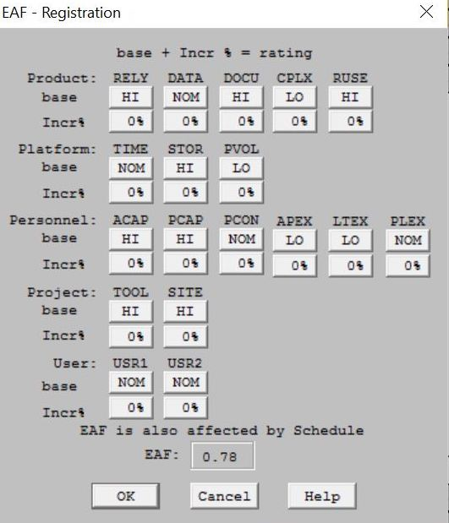

**Figure 2: EAF- Registration**

Table 8: COCOMOII Cost Driver – Payment System

|  |  |  |
| --- | --- | --- |
| **Cost Driver** | **Value** | **Rationale** |
| RELY | High | Payment module involves user’s money and very critical. If this module does not works then users will not be able to make fees payment, donation or buy DVDs online which are “Must Have” features |
| DATA | Nominal | This module will be using Stripe, so it needs good amount of integration testing with Squarespace |
| DOCU | Nominal | Client currently uses PayPal. This module will be using Stripe, which is completely new to client. Therefore, it needs documentation. |
| CPLX | Nominal | This is not complex to develop as team has prototyped this feature. |
| RUSE | High | It is used for three different processes, fees payment, making donations & purchasing online DVDs. |
| TIME | High | It includes COTS integration i.e. Squarespace & Stripe |
| STOR | Nominal | It stores information of all the orders. |
| PVOL | Nominal | No complex hardware/software is required. |
| ACAP | High | Team have good understanding about the customer’s requirements and priorities. |
| PCAP | Very High | Developers have good experience in web development platforms |
| PCON | Low | Not much changes required in this module after full development. |
| APEX | Low | Dependency on developers as not everyone in team have experience in web development |
| LTEX | Nominal | Team has not worked on Squarespace and Stripe before. |
| PLEX | Nominal | Not much advance platforms are required to develop this module. |
| TOOL | High | This module needs to be integrated with Registration Module |
| SITE | High | One member is remote who is in same city. We use Slack, join.me, phone when remote. In addition, we plan to have regular meeting in person once or twice every week. |

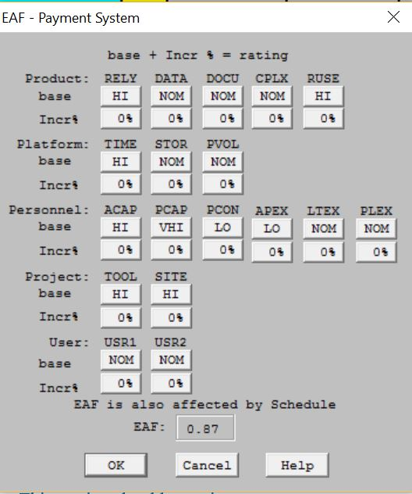

**Figure 3: EAF- Payment System**

Table 9: COCOMOII Cost Driver – Migration

|  |  |  |
| --- | --- | --- |
| **Cost Driver** | **Value** | **Rationale** |
| RELY | High | This module is a MVP and is required for the whole system to be successful. Currently, client has three websites to maintain which needs to be migrated to a single website. |
| DATA | Low | This module does not requires much testing as it will content static web pages. |
| DOCU | Low | This module is migration of static pages and does not require documentation. |
| CPLX | Nominal | This is not complex module, only requires migration of contents. |
| RUSE | Nominal | This module will be used multiple times for migrating contents from three different websites. |
| TIME | Nominal | It requires nominal time as this is not a complex module |
| STOR | Nominal | It requires nominal storage as it contains few static pages. |
| PVOL | Low | No complex hardware/software is required. |
| ACAP | High | Team have good understanding about the customer’s requirements and priorities. |
| PCAP | High | Developers have good experience in web development platforms |
| PCON | High | Not much changes required in this module after full development as these are static web pages. |
| APEX | Nominal | It does not require any complex operations. Everyone in team can contribute. |
| LTEX | Nominal | Team has not worked on Squarespace before. |
| PLEX | Nominal | Not much advance platforms are required to develop this module. |
| TOOL | Low | This module requires simple steps like copy and paste from other websites to new website. |
| SITE | High | One member is remote who is in same city. We use Slack, join.me, phone when remote. In addition, we plan to have regular meeting in person once or twice every week. |

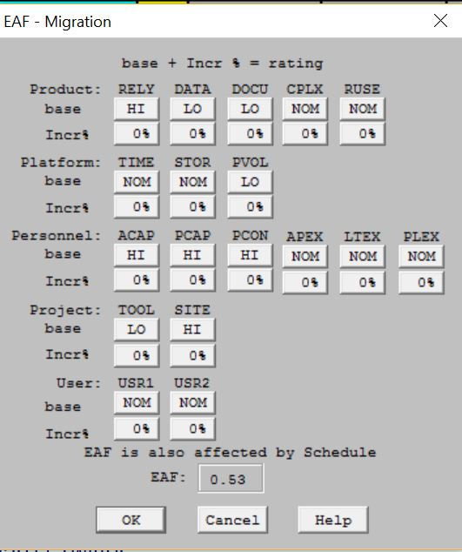

**Figure 4: EAF- Migration**

Table 10: COCOMOII Cost Driver – Announcement

|  |  |  |
| --- | --- | --- |
| **Cost Driver** | **Value** | **Rationale** |
| RELY | Low | The failure of this module will not have much impact on overall system. |
| DATA | Nominal | This module will be using MailChimp so good amount of testing is required. |
| DOCU | Nominal | This module requires good documentation for maintainer, as they will use on day-to-day basis. |
| CPLX | Nominal | This is not complex module to develop but requires COTS integration i.e. MailChimp and Squarespace. |
| RUSE | Nominal | This module will be used multiple times to update website for new events and announcements. |
| TIME | Nominal | This is not complex module to develop but requires COTS integration i.e. MailChimp and Squarespace. |
| STOR | Nominal | It will be using nominal storage, as Announcement will be increased day by day. |
| PVOL | Nominal | It requires COTS integration i.e. MailChimp and Squarespace. |
| ACAP | High | Team have good understanding about the customer’s requirements and priorities. |
| PCAP | Very High | Developers have good experience in web development platforms |
| PCON | Nominal | Maintainer needs to keep updating the information as and when required. |
| APEX | Nominal | Team has not worked on MailChimp before. |
| LTEX | Nominal | Team has not worked on Squarespace before. |
| PLEX | Nominal | Not much advance platforms are required to develop this module. |
| TOOL | Nominal | MailChimp and Squarespace is used for this module |
| SITE | High | One member is remote who is in same city. We use Slack, join.me, phone when remote. In addition, we plan to have regular meeting in person once or twice every week. |

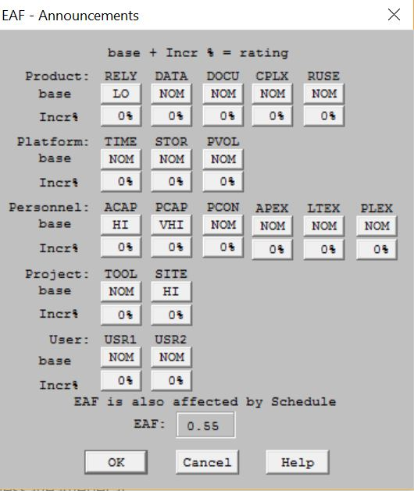

**Figure 5: EAF- Announcement**

Table 11: COCOMOII Cost Driver – Event Calendar

|  |  |  |
| --- | --- | --- |
| **Cost Driver** | **Value** | **Rationale** |
| RELY | Very Low | It is not MVP and other critical modules are not related to this module |
| DATA | Low | This module is straight forward to test as it is not integrated with any other module and does not require much testing |
| DOCU | Low | This module is straightforward to understand and does not requires much documentation. |
| CPLX | Low | This is not complex module to develop. |
| RUSE | Nominal | This module will at multiple places in the system |
| TIME | Nominal | This is not complex module to develop. |
| STOR | Nominal | It requires nominal storage as new events will be added each time. |
| PVOL | Low | No complex hardware/software is required. |
| ACAP | High | Team have good understanding about the customer’s requirements and priorities. |
| PCAP | High | Developers have good experience in web development platforms |
| PCON | High | Maintainer needs to keep updating the information as and when required. |
| APEX | Nominal | No complex application is required for this module |
| LTEX | Nominal | Team has not worked on Squarespace before. |
| PLEX | Nominal | Not much advance platforms are required to develop this module. |
| TOOL | Low | This module is only using a feature of Squarespace, which is simple frontend feature. |
| SITE | High | One member is remote who is in same city. We use Slack, join.me, phone when remote. In addition, we plan to have regular meeting in person once or twice every week. |

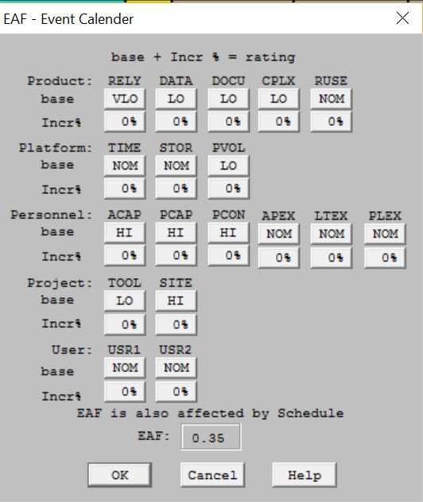

**Figure 6: EAF- Event Calendar**

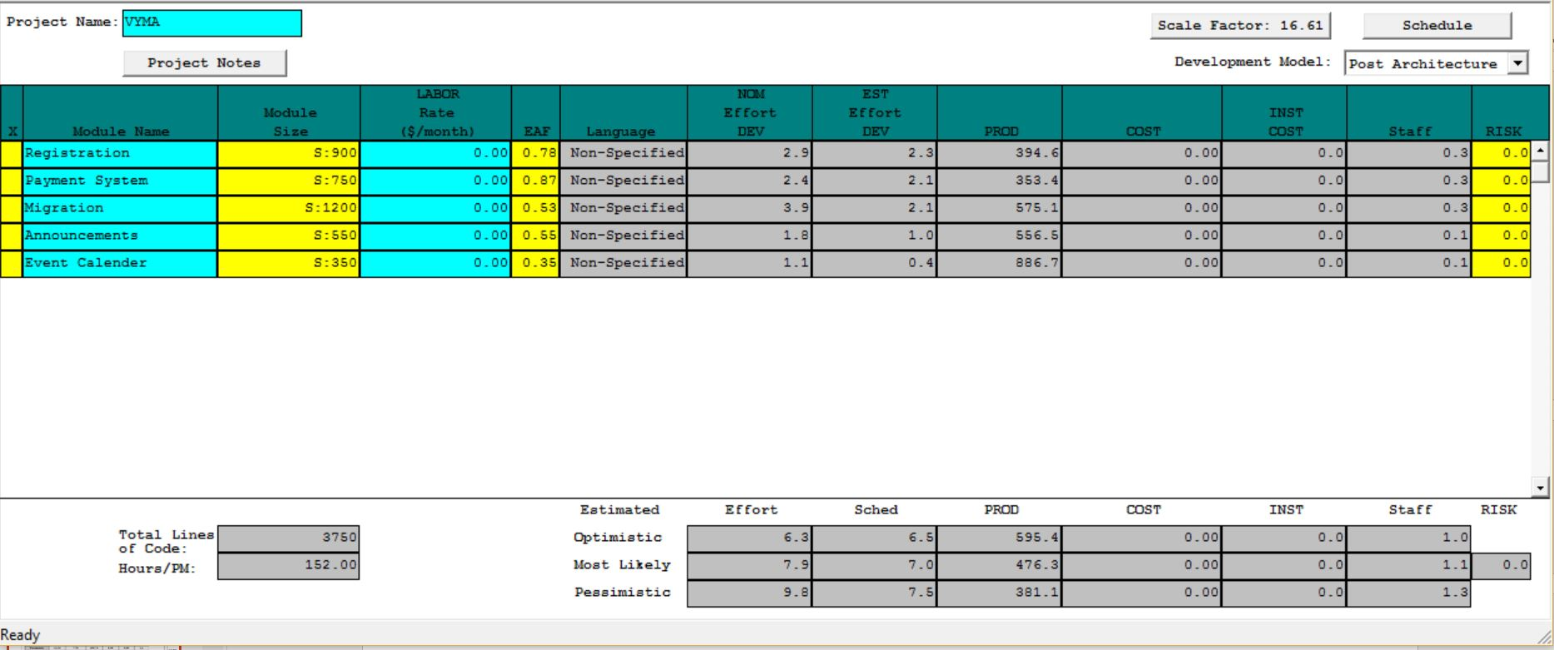

**Figure 7: COCOMO Estimation**

**Estimation:**

* *Efforts (Pessimistic):* 9.8 Person-Month
* *Per Person Efforts:* 18 hours per week
* *Total Time Per Person:* 
  + Monthly Efforts: 18 hours per week × 7 members × 4 weeks = **504 hrs/month**
  + *Total Efforts:* 18 hours per week x 7 members x 12 weeks = **1512 total hours**
* *Time required as per Pessimistic Value:* 
  + Total time(in Months): (9.8 person-month × 152 hours per person-month) ÷ 504 = **2.9 months**
  + Total time(in hours): 9.8 person-month x 152 hours per person-month = **1490 hours**

# 6. Iteration Plan

This section describes the strategy for each iteration in development phase. In each iteration, capabilities are implemented and tested.

## 6.1 Plan

The development phase consists of two construction phases. In first construction phase, must have features of the system are implemented and tested thoroughly. First construction is followed by Core Capability Drive-through in which User Acceptance Testing is done with client to verify that all the User expectations are met for the implemented functionalities. In second construction phase, other remaining features of the system are implemented and tested. This phase is also followed by Core Capability Drive-through (Milestone) where full system is tested by the client. After this, during system transition, training is provided to the client to manage and maintain the system. Finally, fully functional system will be delivered to the client.

### 6.1.1 Capabilities to be implemented

Table 12: Construction iteration capabilities to be implemented

|  |  |  |  |  |
| --- | --- | --- | --- | --- |
| **ID** | **Capability** | **Description** | **Priority** | **Iteration** |
| 1 | **OC-1** | **Online Registration and Payment System:** Students/Parents can register and pay for music courses online. | Must Have | 1 |
| 2 | **OC-2** | **Consolidate three websites:** User can view all the content on one website instead of three. | Must Have | 1 |
| 3 | **OC-3** | **Announcement Section:** User can view all the updates and announcements in announcement section and also receives an email notification for the same. | Must Have | 1 |
| 4 | **OC-4** | **Donations:** Donors can make donations to support VYMA through online payment system | Must have | 2 |
| 5 | **OC-5** | **Event Calendar:** User can view schedule of all the classes and events in event calendar. | Must have | 1 |
| 6 | **OC-6** | **Maintain Registration Process:** Client/Maintainer can check his email and Google Drive for new applicants and their information. | Must have | 1 |
| 7 | **OC-7** | **Download Music Notes:** User can download music notes from password protected page for rehearsals. | Must Have | 1 |
| 8 | **OC-8** | **Roster:** Parents can view other student’s parent’s details on a password protected page. | Mid Priority | 2 |
| 9 | **OC-9** | **Buy DVD:** User can buy DVD of rehearsals and events online. | Low Priority | 2 |
| 10 | **OC-10** | **Contact Us Page:** User can contact VYMA administration for feedbacks and concerns. | Low Priority | 2 |
| 11 | **OC-11** | **Yearbook:** User can view yearbook through a link on VYMA website. | Low Priority | 2 |
| 12 | **OC-12** | **Subscribe to Newsletter:** User can subscribe to VYMA to receive weekly newsletter in his mail. | Low Priority | 2 |

### 

### 6.1.2 Capabilities to be tested

Table 13: Construction iteration capabilities to be tested

|  |  |  |  |  |
| --- | --- | --- | --- | --- |
| **ID** | **Capability** | **Description** | **Priority** | **Iteration** |
| 1 | **OC-1** | **Online Registration and Payment System:** Students/Parents can register and pay for music courses online. | Must Have | 1 |
| 2 | **OC-2** | **Consolidate three websites:** User can view all the content on one website instead of three. | Must Have | 1 |
| 3 | **OC-3** | **Announcement Section:** User can view all the updates and announcements in announcement section and also receives an email notification for the same. | Must Have | 1 |
| 4 | **OC-4** | **Donations:** Donors can make donations to support VYMA through online payment system | Must have | 2 |
| 5 | **OC-5** | **Event Calendar:** User can view schedule of all the classes and events in event calendar. | Must have | 1 |
| 6 | **OC-6** | **Maintain Registration Process:** Client/Maintainer can check his email and Google Drive for new applicants and their information. | Must have | 1 |
| 7 | **OC-7** | **Download Music Notes:** User can download music notes from password protected page for rehearsals. | Must Have | 1 |
| 8 | **OC-8** | **Roster:** Parents can view other student’s parent’s details on a password protected page. | Mid Priority | 2 |
| 9 | **OC-9** | **Buy DVD:** User can buy DVD of rehearsals and events online. | Low Priority | 2 |
| 10 | **OC-10** | **Contact Us Page:** User can contact VYMA administration for feedbacks and concerns. | Low Priority | 2 |
| 11 | **OC-11** | **Yearbook:** User can view yearbook through a link on VYMA website. | Low Priority | 2 |
| 12 | **OC-12** | **Subscribe to Newsletter:** User can subscribe to VYMA to receive weekly newsletter in his mail. | Low Priority | 2 |

### 6.1.3 Capabilities not to be tested

All capabilities will be tested

### 6.1.4 CCD Preparation Plans

Developers will develop new VYMA website which will be tested by the stakeholders on November 16, 2016. Stakeholder joining the CCD are Admin and Director of VYMA. They will use the website to make sure if all the features are implemented and functioning as agreed. They will test by registering and making payment for music courses online, make donation etc. based on our test plan. Also, Order section of Squarespace will be updated with test orders made during testing so that admin can test the order section as well. Test results & feedback from stakeholders will be documented and team will follow up and address all concerns if any.

To make CCD a good experience for all, we will ensure that below points are performed before CCD:

1. Team will make sure that all the required requirements and functionalities are implemented and tested thoroughly.
2. Team will try to use the website and its features putting themselves in stakeholder’s shoes.
3. Make sure all team members are available during CCD.

## 6.2 Iteration Assessment

### 6.2.1 Capabilities Implemented, Tested, and Results

The below capabilities are developed and all modules passed the test cases. For more detailed test scenarios please refer Test Suites related to each capability.

1. Online Registration & Payment Process
2. Consolidate three websites
3. Announcement Section
4. Donations
5. Event Calendar
6. Maintain Registration Process
7. Download Music Notes
8. Roaster Section
9. Contact Us Form
10. Subscribe to Newsletter
11. Buy DVD section
12. Year Book Section

Table 14: Capabilities implemented, tested, and results

|  |  |  |  |  |
| --- | --- | --- | --- | --- |
| **ID** | **Capability** | **Test Case** | **Test Results** | **If fail, why?** |
| 1 | OC-1 | TC-01 | Pass |  |
| 2 | OC-2 | TC-08 | Pass |  |
| 3 | OC-3 | TC-02 | Pass |  |
| 4 | OC-4 | TC-03 | Pass |  |
| 5 | OC-5 | TC-04 | Pass |  |
| 6 | OC-6 | TC-01 | Pass |  |
| 7 | OC-7 | TC-05 | Pass |  |
| 8 | OC-8 | TC-09 | Pass |  |
| 9 | OC-9 | TC-10 | Pass |  |
| 10 | OC-10 | TC-06 | Pass |  |
| 11 | OC-11 | TC-11 | Pass |  |
| 12 | OC-12 | TC-07 | Pass |  |

### 6.2.2 Core Capabilities Drive-Through Results

Use Cases that were tested by client:

1. **Online Registration of music courses & Payment Process:**

Client tested this feature by registering and making an online payment. Client was able to successfully register and pay for the course. This feature worked as expected by the client.

1. **Online Donation:**

Client tested the online donation feature by making a test donation and tested all the related feature like donor receiving ‘Thank You’ email from VYMA and admin getting email about the new donation made by donor. Client confirmed that it is working as expected.

1. **View Announcements:**

Client tested this by browsing to Announcement page under Members section using member password as this is password protected page. Also, client tested by making test announcement at announcement section of the new VYMA website and verified if current members can view the announcement over website and also they received the announcement via email as well. Client confirmed that it is working as expected.

1. **View Event Calendar:**

Client tested this by browsing to calendar page using member password as this is password protected page and verified if the events are listed as required. Client confirmed that it is getting displayed as required.

1. **Download Music Notes:**

All music notes were required to be migrated to new VYMA website and Client tested this by browsing to Music notes under Members section using member password as this is password protected page, by verifying if the music notes have been migrated and also tested if the links are working as expected by randomly downloading few music notes. Client confirmed that music notes were migrated as required.

1. **Feedback & Contact Us form:**

Client tested this feature by filling and submitting the Contact Us form and tested that if Admin is receiving the email with User’s inquiry for the same. Client confirmed that it is working as expected.

1. **Subscribe to VYMA News Letter:**

Client tried the subscription option at Homepage to sign up for VYMA newsletter and verified that if the subscription request is received my Admin. Also, confirmed that user receives an email to confirm the subscription. Client verified by both subscribing and unsubscribing feature. Client was satisfied with implemented feature.

1. **View Roaster Page:**

Client tested this by browsing to Roaster page under Members section using member password as this is password protected page. Client confirmed that it is displaying the information as expected. This page is linked to Google Drive and automatically reflects the changes which are made on Google Drive. Client modified the Google Drive and verified that changes are reflected on Roster Page.

1. **View Video Trailers:**

Client tested this by browsing to Shop section of the webpage which displays all the DVDs available and provides the link to video trailer on YouTube. Client confirmed that it is displaying as expected.

1. **Buy DVD:**

Client browsed to Shop section of the webpage which displays all the DVDs available for purchase. Client tested this by purchasing one of the listed DVD and confirmed that this feature is working as expected.

1. **View all Content at single websites:**

Client tested this by browsing to different section of the new VYMA website to check if all the contents from their old three websites have been migrated. Client confirm that all content is migrated as required.

1. **View Yearbook:**

Client tested this by browsing to Yearbook page under Members section using member password as this is password protected page. Client verified if the link to the Year Book redirects the user to Shutterfly. Client confirmed it is working as required

1. **Manage Registration:**

Client tested by accessing the new VYMA website as maintainer and verified the order section to view all the orders made in the past, verified if all the required fields to maintain the orders are available and also verified if refund can be issued in case of cancelation of registration.

**Feedback from Client:**

**Positive Feedback:** Client was fully satisfied with all the implemented features. Client also presented the new VYMA website to VYMA Board members. They all are really happy with the new system and excited to use it. Specifically, they mentioned that the idea about running the Video in the background at the Homepage conveys the message about VYMA at one glance.

**Improvements/ Suggestions:** Client suggested minor changes to modify few labels on website. She suggested to change the following labels:

* ‘Music Notes’ to ‘Sheet Music’.
* ‘Members’ to ‘My VYMA’

**Changes to be considered:** None as Client is fully satisfied with the new VYMA website and all the implemented features.

**Risks:** No new risks were introduced as all of the risks are already prototyped and mitigated.

**Snapshot of client feedback:**

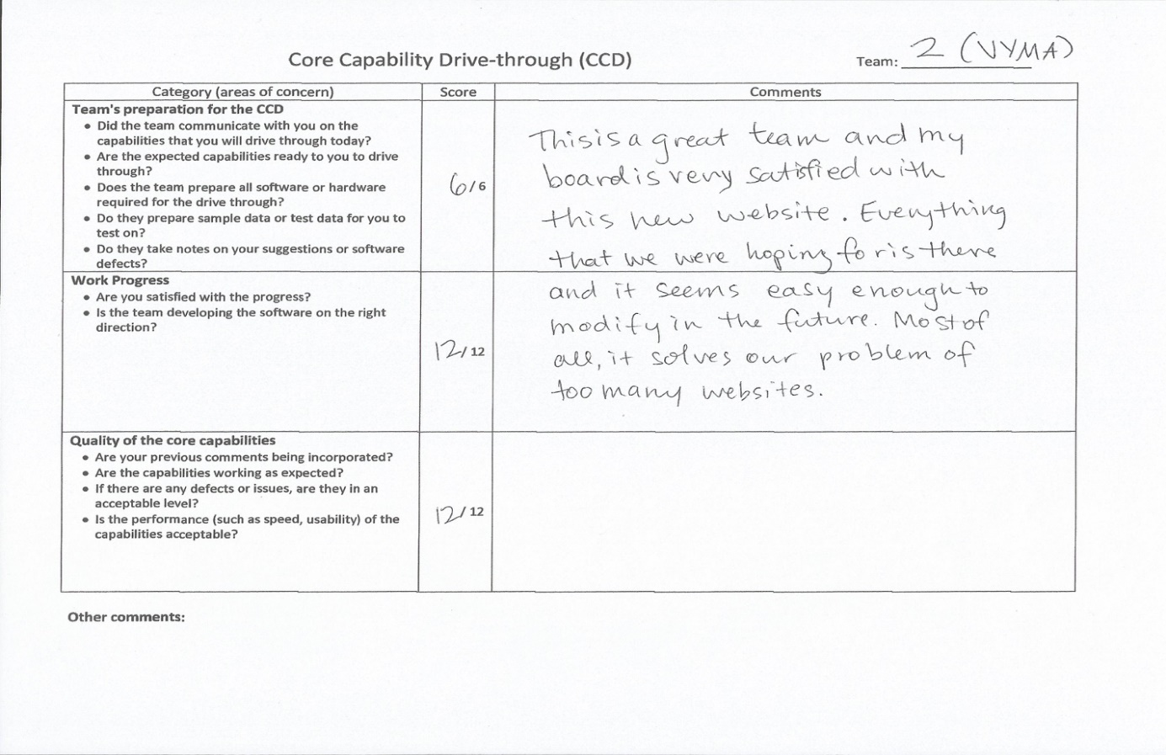

## 6.3 Adherence to Plan

Iteration was successful completely as all the feature are implemented and tested as planned. Client is fully satisfied with the final system. Also, team was able to design and develop all the features within the provided budget meeting all the MVPs as agreed with client.

# 7. Transition Plan:

This section provides the transition plan for VYMA.

## 7.1 Transition Objectives

* Beta test to *validate* that user expectations are met.
* Provide *training* to Client for future maintenance of VYMA website.
* *Transition* the fully functional operable system to client.

## 7.2 Transition Strategy

Transition will be done in following steps:

* Beta Testing:
* *Verify* that operational capabilities for all Win-Conditions are *implemented* and *tested*.
* Provide Training:
* Provide basic *training* of *Squarespace* to Client.
* Provide *technical manual* with clear instructions to maintain and modify the website in future.
* Provide training to use *third party services* like MailChimp and Stripe with Squarespace.
* Transition the System:
* *Host* the Squarespace website on current (vyma.org) domain.
* *Connect* the Client’s *Stripe account* with the Squarespace and test the same with live orders.
* *Connect* the Client’s *MailChimp account* with the Squarespace and test the same with Announcement Section and Subscription functionality.

## 7.3 Software and Site Preparation:

* Software:
* Squarespace
* MailChimp
* Stripe
* Preparation:
* Configure *client’s MailChimp* account with Squarespace.
* Configure *client’s Stripe* account with Squarespace.
* *Host* the Squarespace website on current (vyma.org) domain

## 7.4 Stakeholders and Responsibilities:

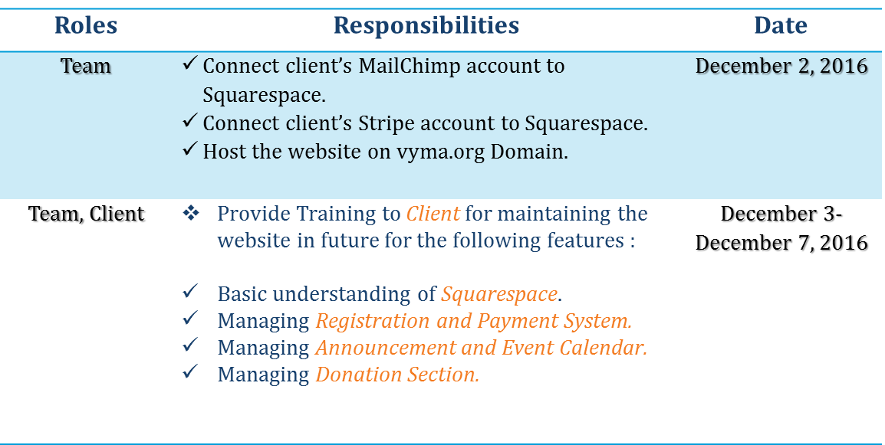

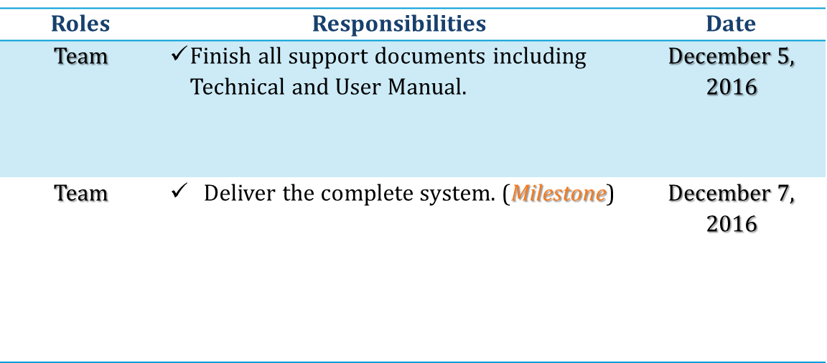

## 7.5 Required Resources:

* Technical Manual:
* Guide to use Basic features of *Squarespace.*
* Guide to manage *Registration* and *Payment System*.
* Guide to manage *Announcement Section* and *Event Calendar.*
* Guide to manage *Donation Section*.
* User Manual:
* Guide for basic *navigational flow* and *functionalities* of website.

# 8. Support Plan:

## 8.1 Support Strategy

* Squarespace Customer Support:
* Squarespace provides *24*7 customer support* as part of its Annual Billing Plan.
* *Online Guide* and *Video Tutorials* are available for all the implemented features of VYMA.
* *Live Chat* Support is available.